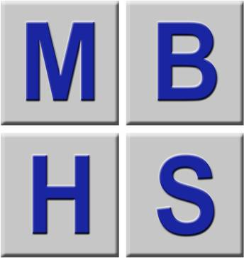 | New & Expectant Mother Assessment  Part 1

Being pregnant or a new mother does not prevent you from working and developing your career. Many women work while they are pregnant and return to work while they are breastfeeding. | 
How to use it
Work through the assessment, ticking either the ‘yes’ or ‘no’ column against each item:
- ‘No’ answers require no further action;
- ‘Yes’ answers may require investigation and may need remedial action. You can record your suggestions for this in the ‘Action to Take’ column;
- The health and safety Manager and the Safety Representative should check later that actions listed have resolved any problems.

What action should be taken
Working through the assessment will identify problems and should also help to suggest action to reduce risks. Employers should carry out adequate risk assessments of all the areas that you work in.
Company Name: Brockhampton Primary School

Name of Employee: Rebecca Hodgkiss

Work Address: Brockhampton School, Brockhampton,
Worcester WR6 5TD

Telephone No:

Date of Birth: 12th July 1994

Expected date of confinement: 26th February 2026

Employed as: Year 6 Class Teacher

Next of kin and relationship: Josh Fletcher (Partner)

Problems to look for when making an assessment | Tick answer  YES NO |  | Ways of reducing the risk |  | Action to take

1.

Discuss any physical situations that may be encountered or that she might be exposed to during her normal routine, which might affect mother and child during pregnancy:
Strenuous Manual Handling |  |  | Reduce the amount of physical work or provide aids. | It was discussed with Rebecca that her role may involve some minor physical aspects; it is recommended that manual handling tasks be minimised wherever possible. Rebecca has confirmed that she has support to assist with these tasks
Exposure to High Noise Levels |  |  | Provide ear protection. | No Action Required
Exposure to lionising radiation |  |  | The wearing of lead aprons and dose meters etc.) minimises the risk. | No Action Required
Exposure to extremes of cold/hot |  |  | Exposure of pregnant women to such environments should be minimised. | No Action Required
Exposure to shocks, vibration or excessive movement |  |  | Reduce work associated with heavy physical work. | No Action Required
Excess physical/mental stress |  |  | Discuss with your Manager. | Please refer to additional notes below
Carrying objects up/down stairs |  |  | Keep one hand on the handrail at all times | Possibly some iPads, but Rebecca has stated that the children assist with this
Biological agents that may be encountered:
Rubella |  |  | Notify other close work colleagues of your pregnancy to notify their manager if they come in contact with Rubella (also known as German Measles) or contact with Chicken pox. | Rebecca is aware of the risks and will take the necessary precautions to keep her and her baby safe
Chicken pox virus
Toxoplasma (preparation of raw foods) |  |  | This is found in different forms in raw meat and cats that eat raw meat and their faeces. | No Action Required
Additional notes:

Rebecca has reported experiencing increased anxiety, poor sleep, and difficulty switching off. She has been working late and has a feeling of unpreparedness, which has contributed to her current stress levels. Additionally, she noted that comments from class parents have been affecting her more than usual.

Rebecca stated that she has strong support both at home and at work; however, It was advised that she contact her GP and midwife as soon as possible to seek professional support and discuss any necessary adjustments. It was also suggested that she raise these potential adjustments with her Headteacher.

Problems to look for when making an assessment | Tick answer  YES NO |  | Ways of reducing the risk |  | Action to take

Any disability:
Wheelchair user |  |  | No Action Required
Hearing impairment |  |  | No Action Required
Dyslexia |  |  | No Action Required
Autism |  |  | No Action Required
Arthritis |  |  | No Action Required
Asthma |  |  | It was discussed that her asthma is well-managed
Bronchitis |  |  | No Action Required
Depression |  |  | No Action Required
Stress |  |  | Please refer to the additional note above
Coronary Heart Disease |  |  | No Action Required
Vision Impairment |  |  | No Action Required
Diabetes |  |  | No Action Required
Epilepsy |  |  | No Action Required
Are you suffering from any of the following:
High blood pressure |  |  | No Action Required
Fainting fits |  |  | No Action Required
Morning sickness |  | Rebecca is suffering from morning sickness | Rebecca has said that this is manageable and does not impact school life. Should this change, Rebecca will speak with the Headteacher
Varicose veins |  |  | No Action Required
Any other condition |  |  | Please see below
If yes, please list below:

Rebecca raised that she has a negative blood type, while her baby has a positive blood type. Rebecca stated that if she experiences any knocks or trauma during pregnancy, she will require an Anti-D injection to prevent complications.

Problems to look for when making an assessment | Tick answer  YES NO |  | Ways of reducing the risk |  | Action to take

2. Risks

Are there any hazardous substance that is present in the working environment?  (if yes please list) |  |  | Re-assess the COSHH assessment, so that no substance is used without having first been fully re-assessed with regard to pregnancy. If substances are used in the working capacity re-check the substance data sheet. |  | No contact with chemicals other than general household cleaning items. Recommend that Rebecca review the labels of chemicals used before use.
Do you use Display Screen Equipment (computer etc.)? |  |  | Re-assess the original workstation assessment |  | Rebecca does use DSE for extended periods and has been advised to complete a DSE assessment at the earliest convenient time, and actions raised should be addressed
Are you required to work overtime, shift work, or nights?  LONE WORKING IS discussed separately |  |  | If yes, can suitable alternative work be found?  Shift work should be avoided if possible  f it cannot be avoided then a specific risk assessment should be completed. The risk assessment should include the GPs opinion. |  | Rebecca is not expected to work overtime or shift work
Are you required to stand or sit for long periods as part of your work? |  |  | Fatigue from prolonged standing has been associated with miscarriage, premature birth, and low birth weight. Long standing should be avoided. |  | It was discussed that if Rebecca finds herself sitting or standing for prolonged periods, it is recommended that she take regular breaks and actively manage her movements.
Do you have to stretch to reach objects or materials on shelves? |  |  | Check the working environment, i.e. High shelves. Low storage. Cabinets. Stooping. |  | No Action Required
Are you likely to be exposed to stressful, aggressive, or even violent situations? (Customer Services, Security Work, Single Staffing in a Petrol Filling Station) |  |  | Is there always support at hand to help staff who may be threatened or abused by Customers? |  | Rebecca has stated she does have a playground duty in the morning, if problems arise, or if there is a chance of a child bumping or colliding with her Rebecca will discuss with her headteacher and if necessary, consideration should be made for this activity to cease.
Do you have to wear personal protective equipment (PPE) or a uniform?  This includes sensible footwear |  |  | PPE is not generally designed for use by pregnant women.  Physical changes around pregnancy may make it too uncomfortable to wear or may mean that it no longer provides the intended protection. Uniforms may also cause a problem, particularly as the pregnancy progresses. |  | No Action Required

Problems to look for when making an assessment | Tick answer  YES NO |  | Ways of reducing the risk |  | Action to take

2. Risks

Are the arrangements for travelling to/from work satisfactory?  (Driving, Public Transport). |  |  | Is the car park accessible to and from the workplace?  Consider how far she has to walk, and the weather conditions such as ice, darkness, rain, fog etc. |  | Rebecca has a 20-minute drive to work and parks in the car park which is near the building. There are no problems currently.
Do you have any special duties, Fire Marshal, Manual Handling Trainer or First Aid? |  |  | If you have special duties such as Fire Marshal, First Aider, and Trainer in Manual Handling, all could be a potential hazard.  Re-assess the impact of being pregnant on these roles. |  | Rebecca, as class teacher, sometimes teaches PE, where physical demonstrations are required; she does not perform them herself
Do you have any lone working in your daily duties?  (i.e. Opening up premises, locking up premises, last person away) |  |  | Measures should be implemented to take account of normal foreseeable emergencies e.g. fire, equipment failure, illness and accidents.  If possible, lone worker alarms should be used or for example two-way radios, telephone checking systems requiring users to report at agreed intervals to security. |  | Does no work alone within the school. There is always someone present.
Welfare facilities  (Toilets, rest areas, food and drink areas). |  |  | Are the toilets readily accessible, not far to walk to?  Are the toilets clean and hygienic?  Is there a designated area for rest periods?  Is there adequate eating areas, and readily available drinking water?  Is the lighting sufficient in the area she works?  Is there adequate ventilation? |  | No Action Required
Is the housekeeping good? (i.e. ensuring items are not left lying around, anti-slip flooring, anti-slip mats and the wearing of sensible shoes) |  |  | Consideration should be given to ensure work areas are safe and clutter-free; this includes keeping aisles, and stairways free from clutter and the arrangements in place for cleaning spills. |  | No Action Required
Are you exposed to x-ray equipment? (in veterinary practices, test labs) |  |  | Unborn children are particularly sensitive to x-rays, therefore wherever possible it is advised not to include pregnant women in work related projects involving exposure to ionizing radiation. |  | No Action Required

Problems to look for when making an assessment | Tick answer  YES NO |  | Ways of reducing the risk |  | Action to take

2. Risks

Has your GP or midwife given you any particular health advice that your employer should be made aware of? |  |  | Do you have someone in authority you can talk to; a buddy? |  | Rebecca has said she feels comfortable talking to the Headteacher

Declaration |  | I am aware of the risks of continued employment as a new/expectant mother. I have been informed of and understand the preventative measures necessary to avoid risk of injury to myself or my child.  My doctor has not identified the activities that might be hazardous to me/my child’s health.  Give details if applicable. Rebecca to advise on any changes
I am prepared and happy to remain in my present employment, and I confirm that I will inform my immediate department head should there be any changes in my medical condition.
I have been given a copy of the ‘New and Expectant Mothers who Work’ leaflet.

I give my consent for Brockhampton Primary school to process my sensitive data and to pass the appropriate details to McCormack Benson Health and Safety for the purposes of conducting and processing my New & Expectant Mother Risk Assessment.

Signature of Employee
Date
Signature of Manager
Date

Advisors Name |  | John Addison
Signature of Advisor |  | 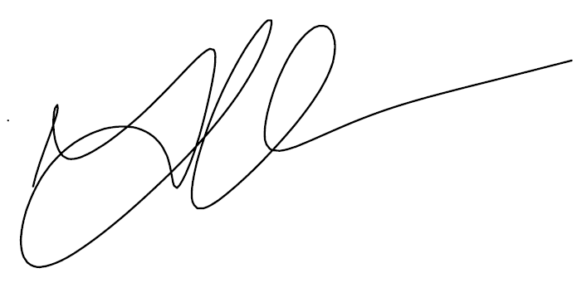
Date |  | 09/10/2025
